|  |  |
| --- | --- |
| **Assignment # 1**  Software Requirement Engineering | |
| Student Name | **Qasim Ali** |
| Registration No | MSCS – **3483** |
| Date | 21 Nov 2019 |
| Assignment | * Choose a software project by your own for an organization in Islamabad. * Identify all stakeholders. Make a list of all the stake holders along with their role and responsibilities. * Filter primary users from the stakeholder list along with their role and responsibilities * Identify all potential sources for requirements other than the stakeholders. * Make a complete list. * Define the system boundary and context of the system. Draw a context diagram of the system by using DFD patterns. |

**IT PROJECT PROPOSAL**

**TEACHER PORTAL FOR ABASYN UNIVERSITY**

Screen Shot

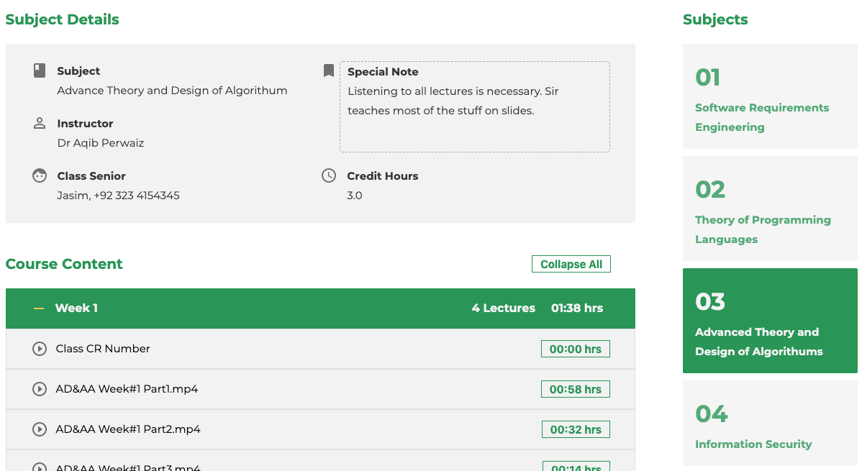

<https://abasyn.herokuapp.com>

Abstract

This project is a personal initiative to reduce the gap between teachers and students at Abasyn University. It has proven beneficial to currently enrolled students at MCSC Fall 2019.

Proposal By

Qasim Ali

Student at Abasyn University

Course – MCSC Fall 2019

Regn No – 3483

Proposal Length

2 x Pages

IT PROJECT PROPOSAL

**TEACHER PORTAL FOR ABASYN UNIVERSITY**

|  |  |
| --- | --- |
| Summary of proposal | Dear Sir,  I have created a teacher’s portal that helps teachers and students stay better coordinated about the course in progress. It also helps students in timely submitting their assignments and staying prepared for upcoming quizzes. I have introduced this project to my class fellows and they liked the concept. They are also using it (I have embedded google analytics in the project). Presently this project is live and can be inspected by visiting the link below:-  <https://abasyn.herokuapp.com>  I believe this portal can prove beneficial to the university in “distributing e-education”. |
| Business Case | * D/L students are only dependent on WhatsApp groups being run by students and mostly miss out important announcements like quizzes and assignments. * Teachers are also unable to effectively correspond with students and announcements are routinely missed out which causes inconvenience. * No other university in Pakistan is currently offering Online Curriculum in format introduced in this teacher’s portal. * If university accepts this proposal, additional features like Students Sign Up to Courses and Text messages-based announcements can be added. |
| Strategical Goal | * Provide a portal to teachers where they can easily interact with students while ensuring no important announcement goes un attended. |
| Preliminary scope statement | * After conduct of a class, teachers can upload particular to class notes, future assignments, lectures and videos (if recorded on google drive). * All students who have Signed Up by paying university fee to courses of their choice can find course data at a unified place. * Unlike WhatsApp feed, that becomes impractical after a certain time. |
| High Level Deliverabilities | * Centrally manage content. * Build organized courses as these are taught over the course duration. |
| Critical Success Factors | * Uploading curriculum is the foundation concept of this project, that has to be ensured by Teachers, Class Seniors or IT Assistant * Affiliation of this project to University’s default URL |
| Requested Implementation Date | Spring 2020 Undergraduate and Graduate Courses |

|  |  |  |  |  |  |  |
| --- | --- | --- | --- | --- | --- | --- |
| Project Risk Assesment | | | | | | |
| Risk Event | | | | Probability | | Impact |
| University administration’s interest in this project reduces if enough creativity is not poured into the development of future features | | | | High | | 100 % Failure |
| Features promised in the project are not delivered and it becomes un-trustworthy to use. | | | | Medium | | 50 % Failure |
| Teachers do not find this project useful and stop using it | | | | Low | | 20 % Failure |
| Assumptions | * Fee Collection procedure is not part of this project. * At least 1x IT Person from University Staff needs to be involved to keep this project running. * Regular maintenance of project by the developer is necessary. | | | | | |
| Constraints | | | | | | |
| Budget Constraints | Technology Stack | | Staff Involvement | | | |
| Server Cost:-   * USD 7.00 / month   Maintenance Cost:-   * USD 100.00 / month | * Nodejs * MongoDB * Handlebars * Express * Uploading of data using Excel (Basic Version) * HTML * JavaScript * CSS * jQuery * GitHub for version control | | * Teachers of respective Courses * Class Seniors * IT Specialist | | | |
| Proposed Cost | Integration Cost (1 time): USD 1000.00  Maintenance Cost (per month): USD 100.00 | | | | | |
| Stakeholders | * Teachers * Students * University | | | | | |
| Business Unit | Contact Person | Contact | | | Involvement | |
| https://www.qasimali.xyz | Qasim Ali | 0323 5168638  [qasimali24@gmail.com](mailto:qasimali24@gmail.com) | | | * Development * Design * Maintenance | |
| Registration No: 3483  Course: MCSC Fall 2019 | | | |